P.L.E.D Instruction Manual

*Precision. Grace. Beauty. Fire.*



Contents

**No table of contents entries found.**

*Introduction*

PLED is a revolutionary new design for CNC based laser engraving machines. It allows its users to construct a working laser engraver for as little as $700 which is far below the asking price of commercially available units. It has 2 main components. The operator first uses the PLED program on the PC to choose, size, and position an image. The second component is the gantry which the user then selects a wood plaque of their liking, sets some mechanical adjustments, and locks the plaque in place. The engraving programs begins, and an engraved image comes to life on the plaque. The engraving procedure in this document will outline how to perform and engraving using the PLED.

*Required Equipment and Expertise*

PLED is designed to be constructed by the user. The microcontroller, wiring, laser, motors, and gantry components need to be properly assembled before performing the engraving procedure. This requires an intermediate to advanced knowledge of electromechanical construction. The engraving procedure itself is simple enough for any adult to learn to operate. With that being said, please follow all safety warnings detailed in this document to the fullest extent. Failure to do so may result in permanent blindness and severe injury.

Before performing the engraving procedure, perform a check to ensure the following components and present and assembled in a sturdy manner:

(2) NEMA 17 bipolar stepper motor

(2) Cylindrical 4 wire rotary encoder

(2) SainSmart stepper motor driver

(1) 445 nm laser diode

(1) Laser shielding hood

(1) 445 nm laser safety glasses

(1) FlexMod p3 laser driver

(1) Assembled mechanical gantry

(1) Tiva C TM4C123GH6PM microcontroller

(1) UART to USB serial adapter cable

(1) Wood plaque with width and length not exceeding 14.4 inches

*Engraving Procedure*

1. Choose the perfect picture! If you are putting forth the effort to buy a nice piece of wood and are willing to wait 5 hours to engrave, you want to make sure your picture is worth the effort. Once you have find the right picture, open PLED.exe on the PC. You will see the window open as shown below:

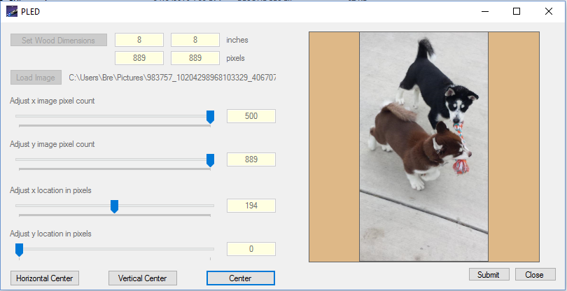

Begin by selecting the dimensions of the wood plaque you have chosen. You do this by clicking on “Set Wood Dimensions”, then entering the X axis width and Y axis length of the plaque. Click Set Dimensions” to continue.

1. Now that the dimensions have been set, click the “Load Image” button and select your image. You have the option of scaling the image vertically or horizontally by clicking and dragging the “Adjust x image pixel count” slider bar or the “Adjust y image pixel count” slider bar. Changes will be displayed in the preview window to the right.
2. You also have the option to position your image on the wood plaque. This can be done manually by clicking and dragging the “Adjust x location in pixels” slider bar or “Adjust y location in pixels” slider bar. Additionally you can horizontally, vertically, or absolutely center the image automatically by selecting one of the three buttons below. All changes will update immediately in the preview window on the right.
3. Now insert your wooden plaque into the drawing area in the gantry as shown in the image below. Be sure to align the wood by assuring it is flush with the aligning fence to ensure your graphic will be engraved on the plaque as you set in the engraving program. Make sure that the 12V DC plug and power supply are both switched on and that the LED on the microcontroller is red, indicating it is active.
4. Return to PLED.exe on the PC and click “Submit”. The program will begin the engraving process and you will see an estimated engraving time. While the unit is engraving, please follow all common safety practices by wearing protective 445 nm laser safety glasses when opening the hood. After the engraving is complete, be sure to close PLED.exe and turn off the power supply to save power.